Given the root of a binary tree and two integers p and q, return *the* ***distance*** *between the nodes of value* p *and value* q *in the tree*.

The **distance** between two nodes is the number of edges on the path from one to the other.

**Example 1:**

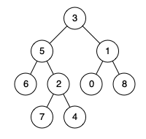

Input: root = [3,5,1,6,2,0,8,null,null,7,4], p = 5, q = 0  
Output: 3  
Explanation: There are 3 edges between 5 and 0: 5-3-1-0.

**Example 2:**



Input: root = [3,5,1,6,2,0,8,null,null,7,4], p = 5, q = 7  
Output: 2  
Explanation: There are 2 edges between 5 and 7: 5-2-7.

**Example 3:**



Input: root = [3,5,1,6,2,0,8,null,null,7,4], p = 5, q = 5  
Output: 0  
Explanation: The distance between a node and itself is 0.

**Constraints:**

* The number of nodes in the tree is in the range [1, 104].
* 0 <= Node.val <= 109
* All Node.val are **unique**.
* p and q are values in the tree.